**AWS PROJECT**

### Lab 1: Setup Website folder structure locally.

* + Create a portfolio website using HTML.
    - Website should have 1 Home Page, 4 Subpages and 1 Error Page.
      * Home Page- [Index.html]
      * Subpages- [About.html, Portfolio.html, Blog.html, Contact.html]
      * Error Page- [404.html].
    - Home Page should have menu containing links to navigate to all the subpages.
    - Every page should have Header tag containing Page name and paragraph with some relevant content.

**SOLUTION:**

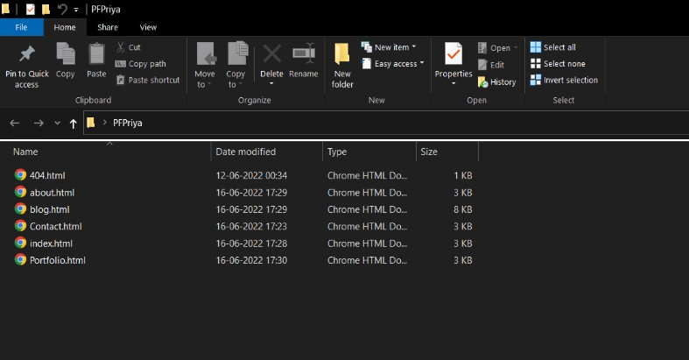

Normal HTML Website ( used for EC2’s and ALB labs)

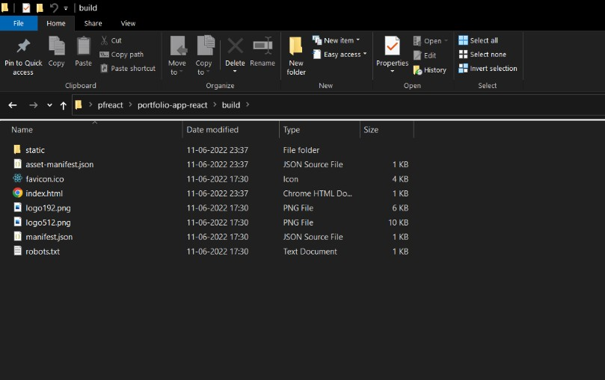

React Portfolio website ( used for S3 and cloudfront ) .

### Lab 2 : Setting up Website using S3 Bucket.

* + Create a S3 bucket
  + Setup following bucket access policy.
    - Bucket object should be accessible only on VPN IP Address
    - No one should be able to list the Bucket Objects.
    - Disable the write permission on Bucket.
  + Upload the portfolio website in the S3 bucket.
  + Setup Website configuration
    - Set Index.html page as the Home Page.
    - Set 404.html page as error Document.
  + Test the setup,
    - Try accessing the Website using S3 Bucket URL (It should load the home page by default).
    - Navigate to all the subpages using home page.
    - Try giving invalid page name in the URL (it should load 404 Error page)

### SOLUTION:

* Login to the AWS Console and go to S3.
* Create a bucket named “ portfolio-priya “.
* Upload the files and folder of the related website.
* Go to S3 > portfolio-priya > Properties > Static website hosting:
  + Enable it. And configure the index and error page.
  + Save it and you will get a url generated.
* Go to S3 > portfolio-priya > Permissions > Block Public Access:
  + Unblock all public access.
* S3 > portfolio-priya > Permissions > Bucket Policy:
  + Edited bucket policy: I created new policy from AWS Policy Generator. Added GetObject BucketPolicy and made this Bucket ‘publically accessible’
* Save the policy and test the URL:

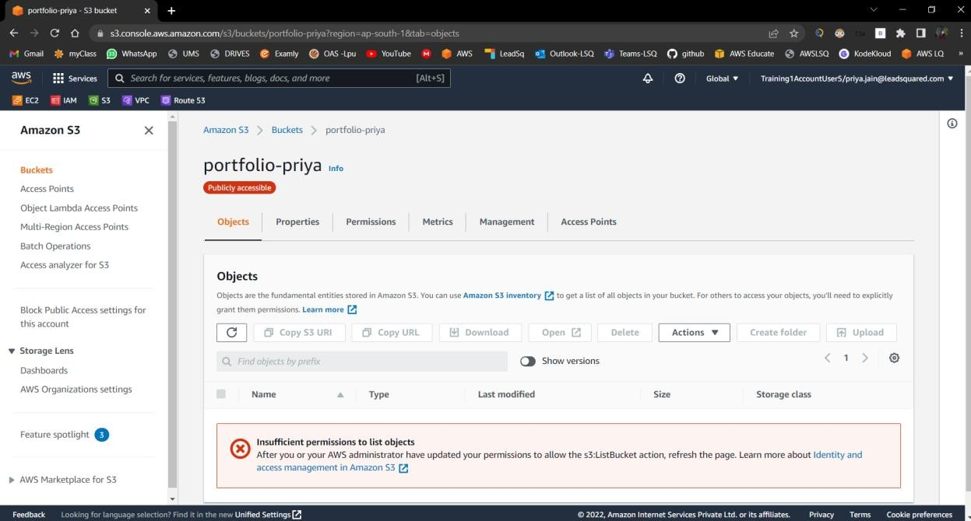

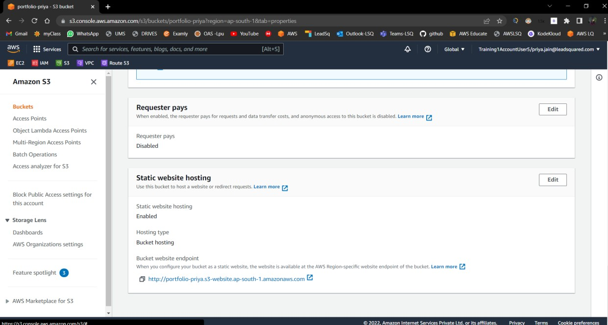

Above shows: Set up the static website hosting ,main page : index.html and error page : index.html [ In react ,re-routing of .jsx components takes place internally ]

The static website endpoint [ [http://portfolio-priya.s3-website.ap-south-1.amazonaws.com](http://portfolio-priya.s3-website.ap-south-1.amazonaws.com/) ]

worked as following:

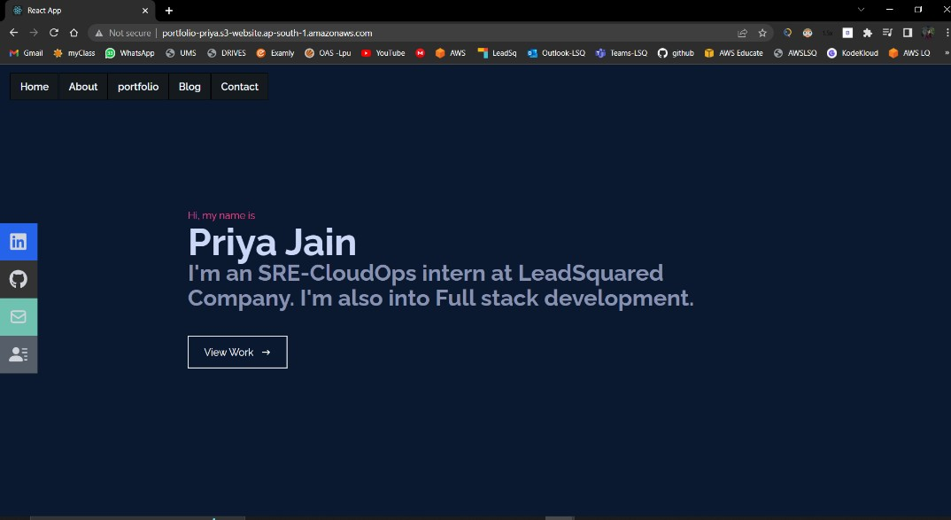

Loaded home page by default

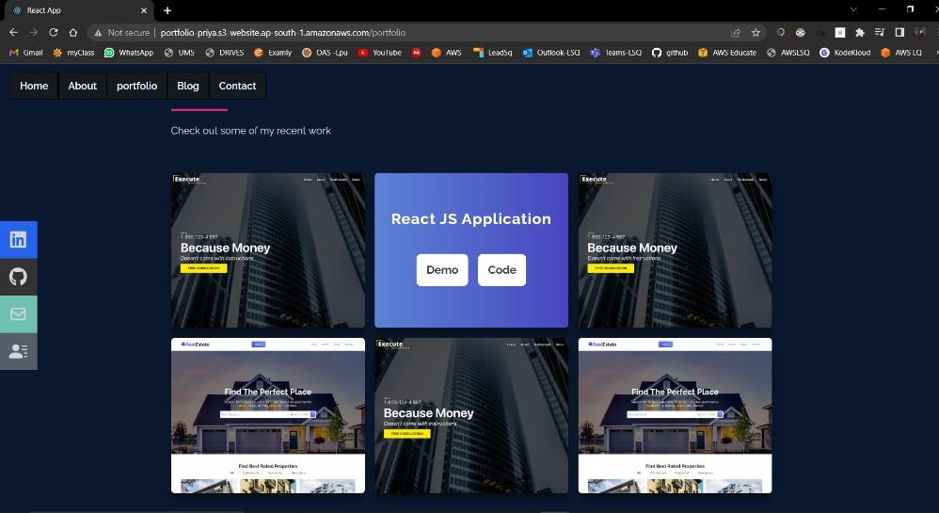

Error Page [ when typing any unknown url-path]:

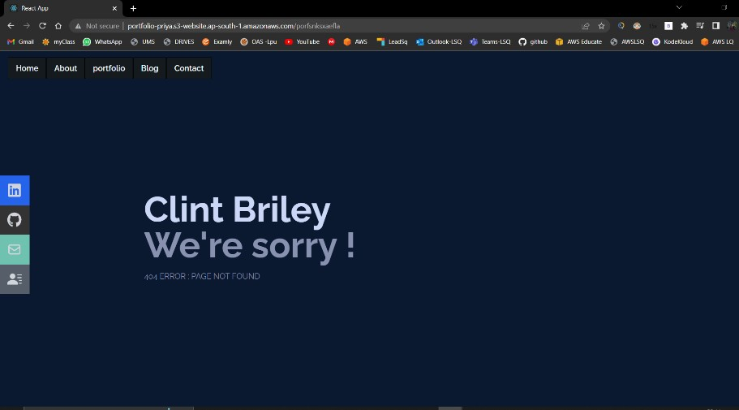

* **Lab 3: Expose the above created Website using CloudFront.**
  + Setup CloudFront distribution for the above S3 Bucket.
  + Configure Index page and Error page.
  + Test the setup,
    - Try accessing the Website using Custom Domain (It should load the home page by default).
    - Navigate to all the subpages using home page. (Domain should not change during navigation)
    - Try giving invalid page name in the URL (it should load 404 Error page).

**SOLUTION:**

* + - Initial steps : CloudFront > Distributions > Create Distribution
    - Some necessary Settings: Origin as s3-bucket details, OAI :yes , Viewer protocol policy : HTTP and HTTPS , default root object as ‘index.html’ page.

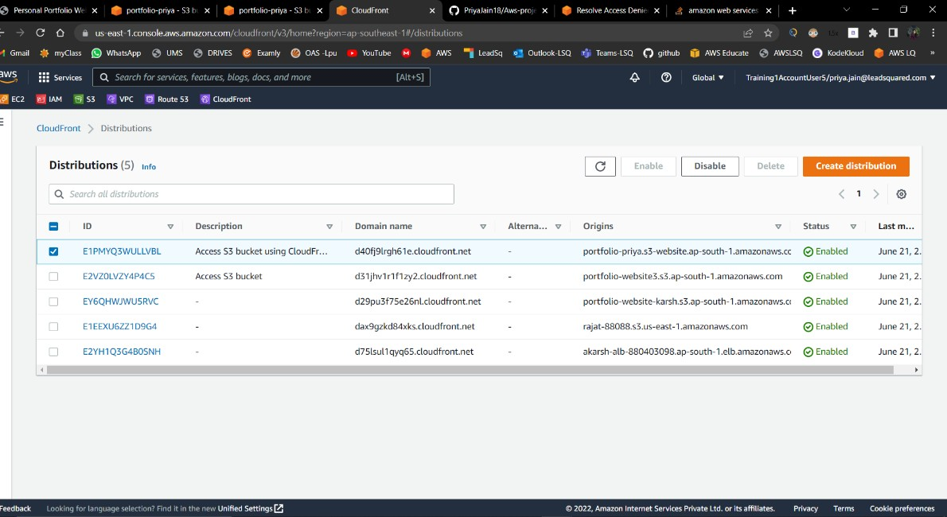

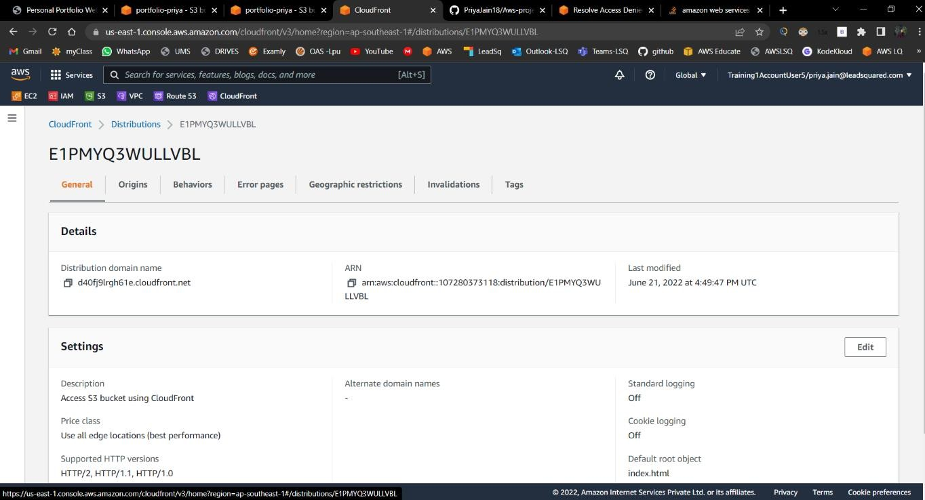

Set Error Pages for ‘404’ and ‘403’ errors .

Access using CloudFront Link : [https://d40fj9lrgh61e.cloudfront.net](https://d40fj9lrgh61e.cloudfront.net/)

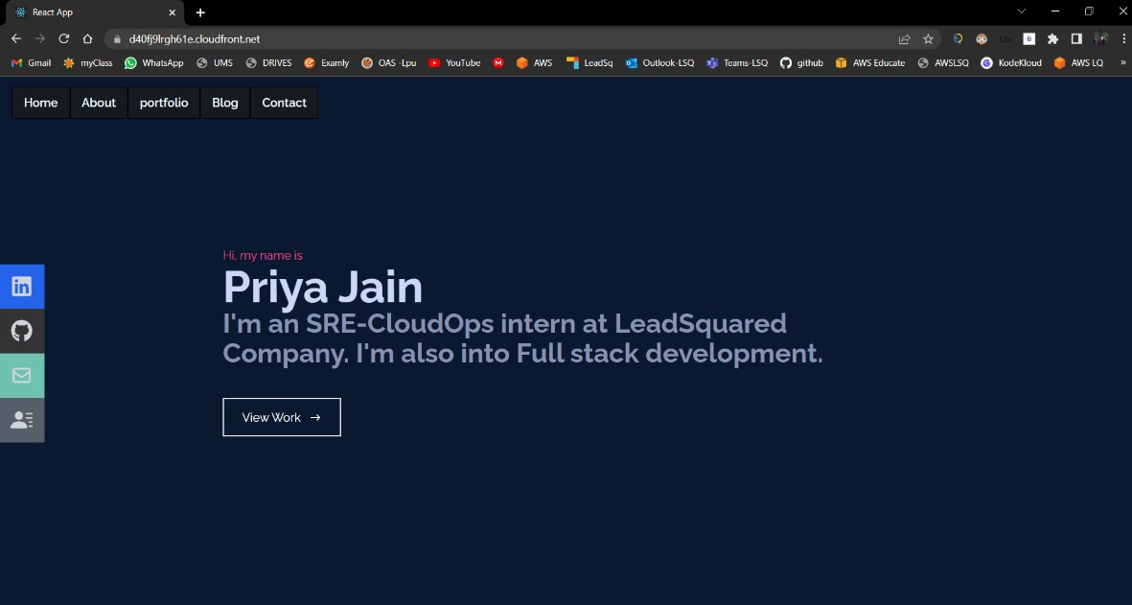

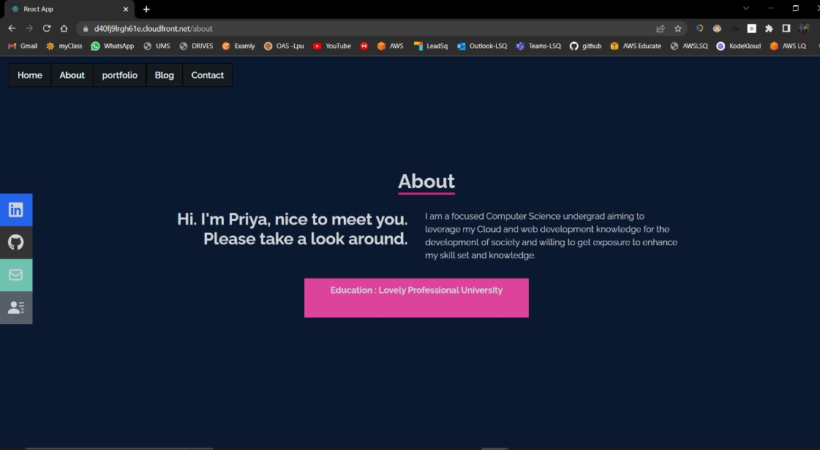

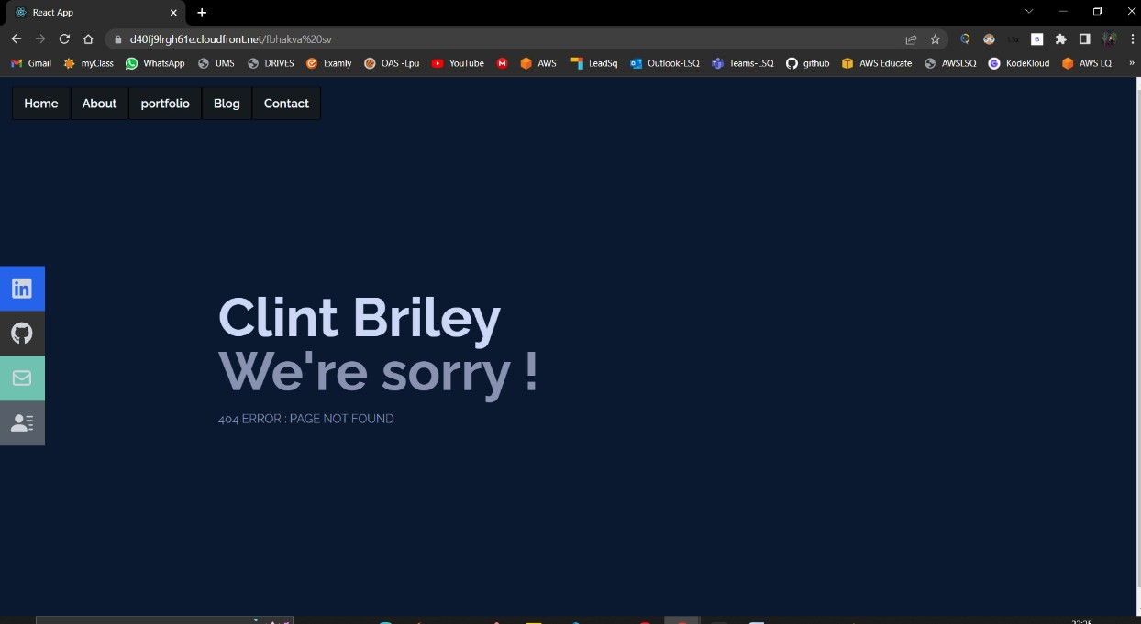

Error page shown above for some random url-path.

### Lab 4: Setup Website using EC2 instance and Custom Domain (A Record) (Domain name was shared by LSQ).

* + Setup Networking
    - Create A VPC with Default Tenancy [Hint CIDR]
    - Create Public and Private Subnet in 2 different AZs.
    - Create Internet Gateway and Route Table.
  + Launch On-Demand EC2 instance
    - Windows OS
    - t2.micro instance type.
    - EBS Volume 30 GB (Free tier)
      * Enable Delete on termination.
    - Enable - Delete protection
    - Strong Password.
  + Login to the EC2 instance
  + Setup IIS.
    - Upload the portfolio Website folder structure in any of the drive.
    - Create a Website in IIS pointing to the above folder.
    - Setup binding
      * Local binding
      * HTTPS binding with Custom Domain.
    - Setup Index page and Error page.
  + Setup EC2 Security
    - Website should be accessible only on HTTPS. [hint- Security group]
    - EC2 should be remotely accessible only on VPN IP address. [Hint RDP]
  + Setup Custom Domain
    - Go to AWS Route53 Service.
    - Create record set and point to EC2 instance, [Type - A Record].
  + Test the setup.
    - Try accessing the Website using Custom Domain (It should load the home page by default).
    - Navigate to all the subpages using home page. (Domain should not change during navigation)
    - Try giving invalid page name in the URL (it should load 404 Error page).

### SOLUTION :

VPC named ‘priya-vpc’ created with default tenancy:

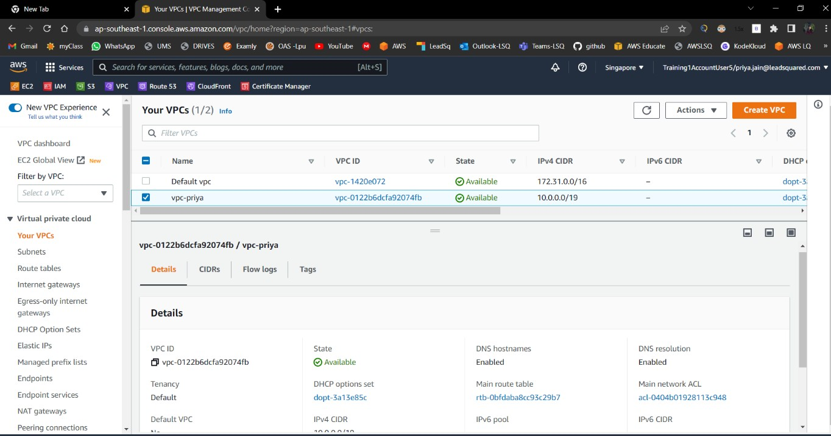

Created Private and public subnets in AZ-a and AZ-b :

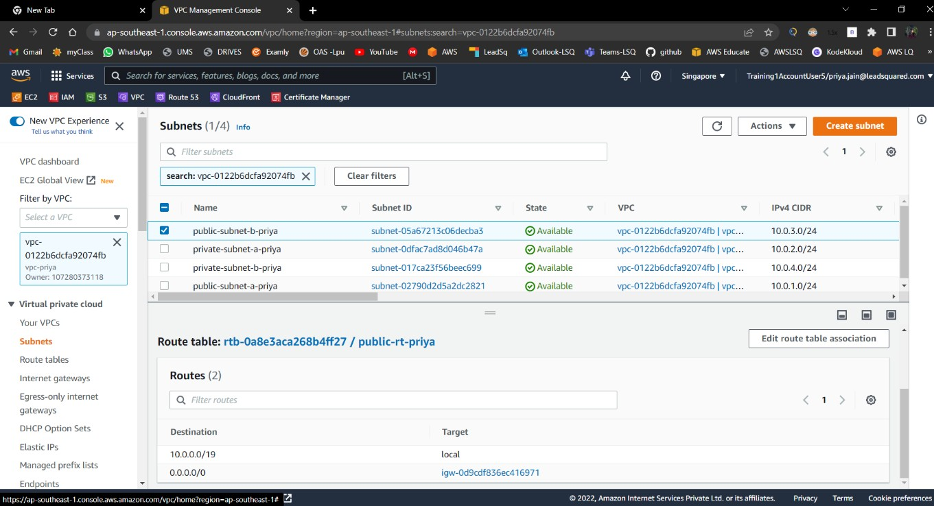

Above shows the 4 subnets created in AZ A and B (2 in each) and ‘public-subnet-a-priya’ and ‘public subnet-b-priya’ is connected to IGW created as shown below:

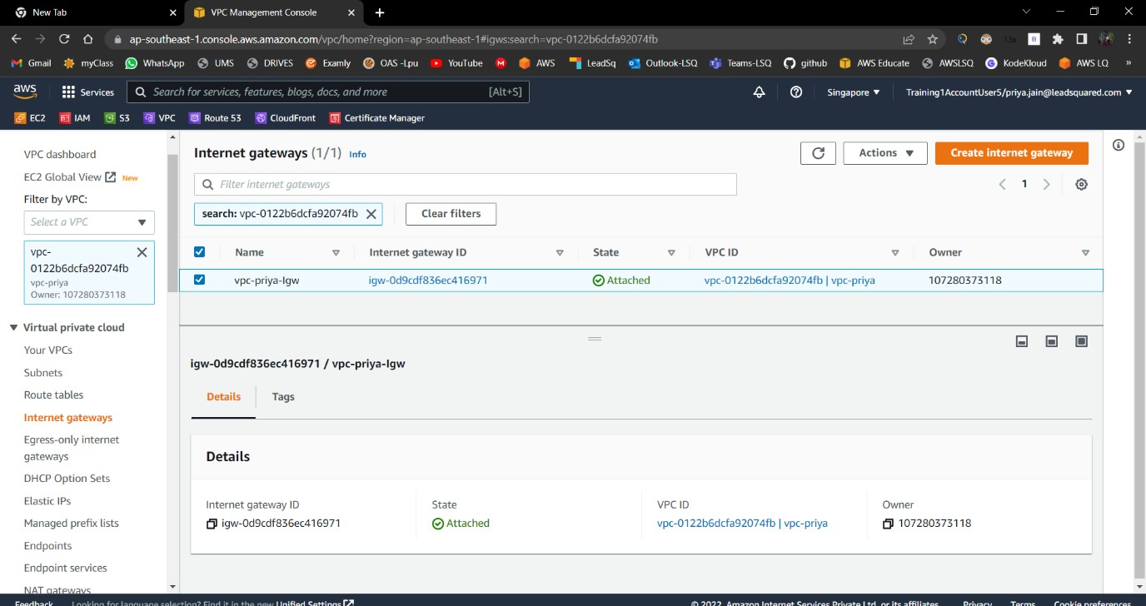

Created Windows t2. Micro EC2 instance as shown below with mentioned in new ‘priya-vpc’:

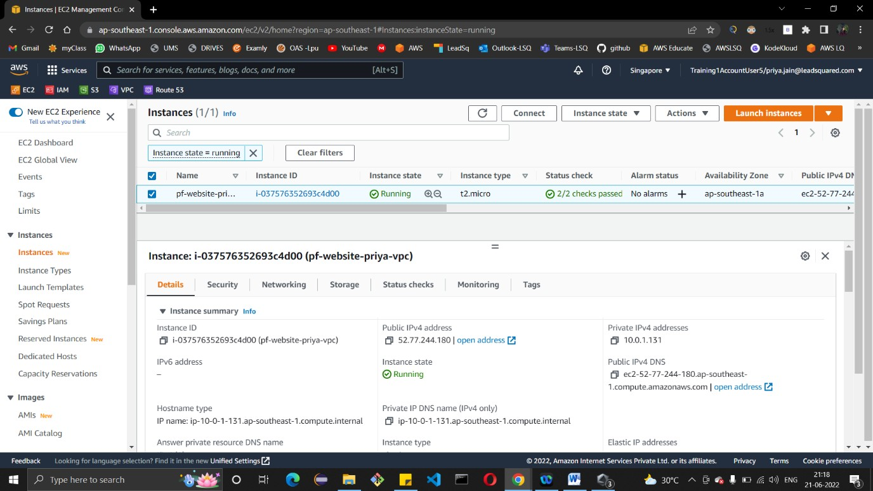

* **Lab 5: Setup Website using EC2 instance and Custom Domain (A Record)**
  + Use the already launched On-Demand EC2 instance.
  + Setup ALB
    - Create ALB
    - Create Target group and attach the EC2 instance behind it.
      * Configure suitable Routing Algorithm. (Least outstanding or Round Robin)
    - Attach Target group to ALB.
      * Configure Listeners and forward the traffic to Target group.
        + Redirect HTTP traffic to HTTPS. [Hint- No Target Group attached]
      * Configure Health Check.

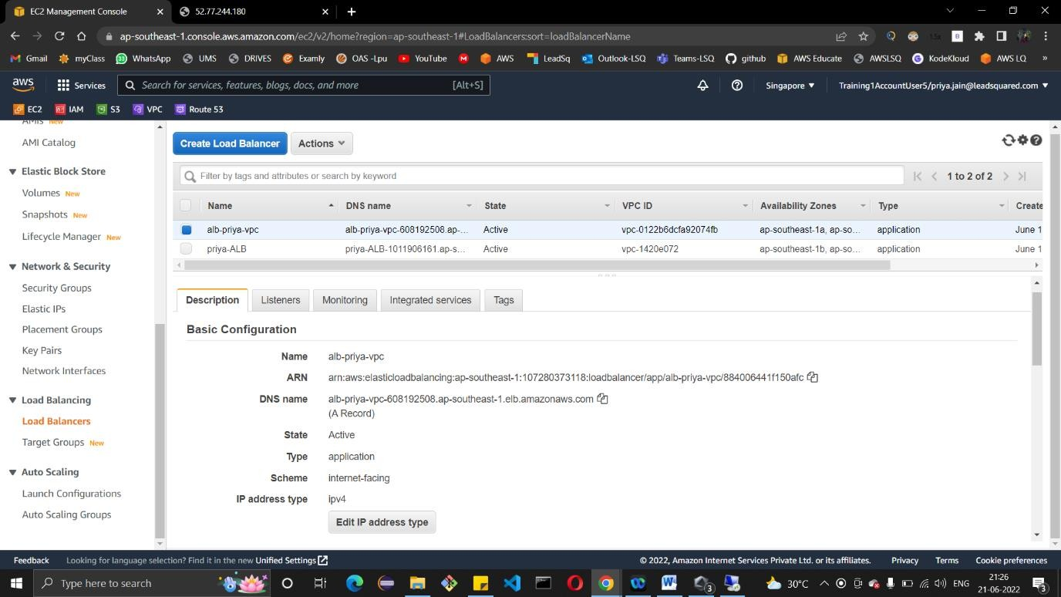

* + Setup ALB Security
    - ALB should accept HTTPS traffic. [hint- Security group]
  + Setup EC2 Security.
    - EC2 should accept traffic only from ALB. [hint- Security group].

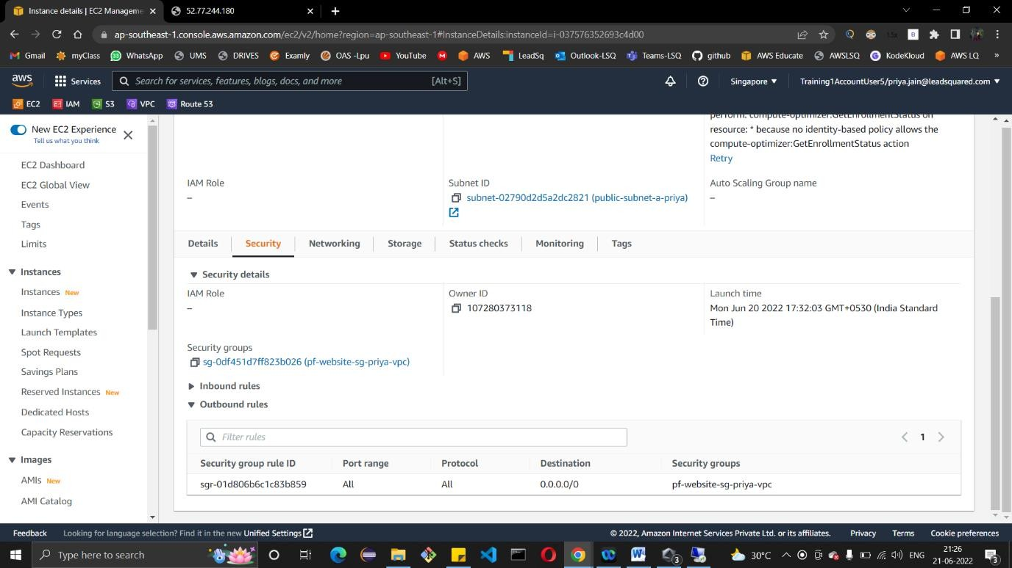

* + Setup Custom Domain
    - Go to AWS Route53 Service.
    - Create Custom Domain and point to ALB, [Hint- CNAME Record].
  + Test the setup.
    - Try accessing the Website using Custom Domain (It should load the home page by default).
    - Navigate to all the subpages using home page. (Domain should not change during navigation)
    - Try giving invalid page name in the URL (it should load 404 Error page).

